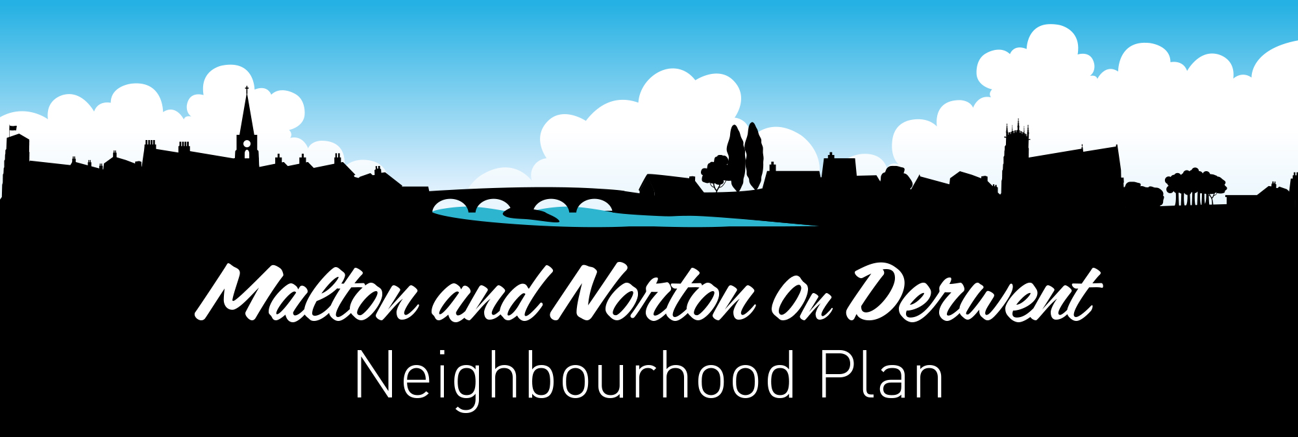

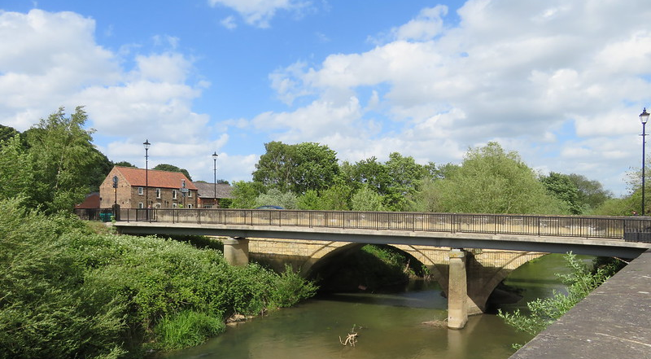
NEIGHBOURHOOD PLAN FOR MALTON AND NORTON
2nd PRE-SUBMISSION PLAN FOR CONSULTATION
PLAN SUMMARY JANUARY 2023

INTRODUCTION
Welcome to this summary of our 2nd Pre-Submission Neighbourhood Plan for Malton and Norton.
This is the second version of the Neighbourhood Plan issued for public consultation. The first version has been updated following decisions by Malton and Norton Town Councils to withdraw the previously submitted plan and propose certain amendments. This leaflet explains these changes and the policies included in the plan.

The underlying Vision and Objectives of the Neighbourhood Plan have not changed. These are based on Malton and Norton boasting a rich heritage and culture, from their historical origins and archaeological and architectural legacy to their surviving traditional horse racing and food-based industries. These are the bedrocks on which our future vision for the towns are based. We look forward to enjoying two towns which have enjoyed appropriate housing and employment growth and opportunity, within the context of an even higher quality environment, consistent with their status as Ryedale’s principal towns.
WE WOULD LIKE TO HEAR FROM YOU WITH YOUR COMMENTS ON THE PROPOSED AMENDMENTS, BUT ALSO ON THE WHOLE PLAN AS WELL IF YOU DO HAVE ANY COMMENTS ON ITS UNCHANGED POLICIES.

Following the consultation, the plan will be amended in the light of comments received. The amended plan will then be re-submitted to RDC or its successor local planning authority, North Yorkshire Council (NYC), for a six-week Regulation 16 publicity period, accompanied by updated supporting documents. There will then follow an independent examination. Subject to a successful outcome and any amendments as required by the examiner, the plan will then proceed to a community referendum of all registered voters on the electoral role within the Neighbourhood Area. If a majority are in favour, the Neighbourhood Plan will then be ‘made’ (i.e., adopted) by NYC as part of the statutory development plan for the area. From that point onwards, it will become the starting point for deciding on planning applications within the Malton and Norton Neighbourhood Area.

To view the full Neighbourhood Plan, supporting documents, and an online response form for your comments, please go to www.nortononderwent.co.uk/malton-norton-neighbourhood-plan/ and www.malton-tc.gov.uk/malton-norton-neighbourhood-plan/ . A hard copy response form is available on request, although we strongly encourage you to use the Survey Monkey online form as this makes it easier for us to process your responses.
The plan will also be available to view at the following public locations around the town:
- Malton Town Council, The Wesley Centre, Saville Street, Malton, YO17 7LL
- Norton on Derwent Town Council, 84b Commercial Street, Norton, YO17 9ES
- Malton Library, St Michaels Street, Malton
- Norton Library (The Hive), Commercial Street, Norton.
The consultation will run for 6 weeks from Friday 27th January to Friday 10th March.
PROPOSED POLICY AMENDMENTS

In this version of the plan certain policies have been amended to offer greater protection against large scale unsustainable development along with other environmental protections. The changes from the first version are summarised below.

- Removal of a pedestrian, cycleway and bridleway improvement route from Middlecave Road-Malton Community Sports Centre (via Malton School Grounds) (TM1). REASON: Objections from the school on safeguarding grounds.

- Strengthening policies relating to the provision of cycle parking (TM1). REASON: There are currently insufficient places to securely park cycles. Active Travel is encouraged and there is increasing demand from cyclists visiting the area.

- Removal of a proposed vehicular junction at Braygate Road/Castle Howard Road and the A64 (TM3). REASON: There is no technical evidence provided to support this proposal in terms of design, cost, land take or its impact on the AONB. It is not evidenced as a realistic or deliverable proposal.

- Amending the policy relating to a potential Southern By-pass. The new policy states this is supported, subject to further technical assessment (TM3). REASON: it has not been possible yet to identify a route for a Southern By-pass and until this has been done, the previous policy, which looked to prevent development which would prejudice the achievement of a by-pass, is considered to be unimplementable.

- An additional Local Green Space Designation for the area to the west of Malton, known as High Malton (land between Castle Howard Road, Middlecave Road, and the A64) (E1 and Appendix 1). REASON: Additional protections against development are to be sought through a Local Green Space designation for this area reflecting its location as part of the setting for the Howardian Hills AONB, it is high amenity value and the high value placed on it by the local and wider community as a special open space resource.

- Strengthening policies relating to the Malton Air Quality Management Area (AQMA) (E6). REASON: increasing concerns over the health risks linked to pollution arising from congestion and the need to ensure the impact of new development is mitigated.

- Amending the policy relating to Castle Gardens to provide protection against the removal of trees (HD4). REASON: Loss of trees would harm this much loved recreational area which is a haven for wildlife and biodiversity.

UNCHANGED PLAN POLICIES

TRANSPORT AND MOVEMENT
- Expect new development to safeguard, enhance and extend pedestrian, cycling and bridleway provision in Malton and Norton, including improvements at 7 specified locations (TM1)
- Resist development at 3 specified locations which would prevent new pedestrian and cycle crossings of the River Derwent and York/Scarborough Railway Line (TM2)
- Resist development at 2 specified locations which would present opportunities for highway improvements in order to relieve congestion through Malton and Norton and support a Southern By-pass (subject to technical assessment), (TM3)
- Support highway management improvements at the County Bridge Level Crossing (TM4)
- Resist development at 2 specified locations which would prevent the creation of a new road crossing of the River Derwent and/or the York/Scarborough Railway Line (TM5)
- Require an assessment of transport impacts for larger sites ((TM6), require electrical vehicle charging infrastructure (TM7) and support provision of a Traffic Management Plan by developers as part of any planning application for major development (TM8)
THE RIVER CORRIDOR
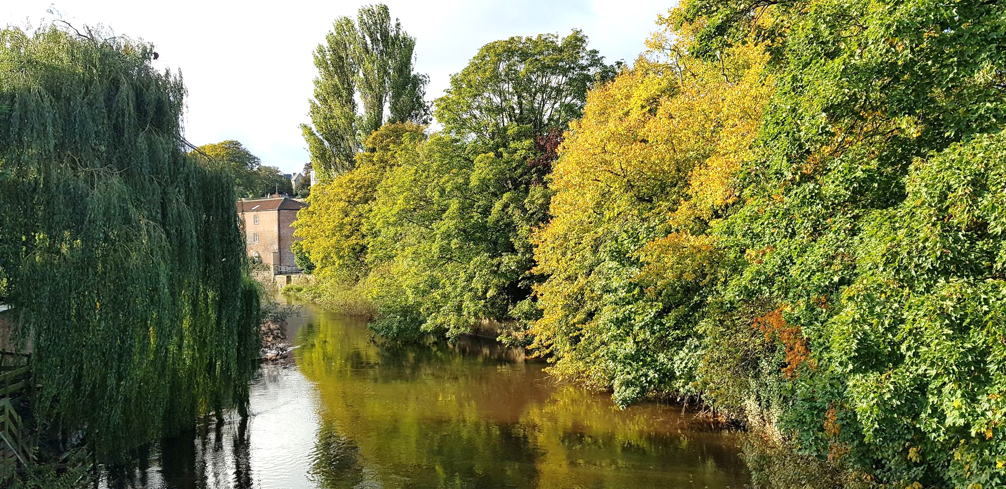
- Support recreational enhancement works, improved access along the river frontage and provision of café/refreshment facilities, subject to fully satisfying conservation, flood risk and landscape requirements (RC1)
- Support regeneration of the land north and south of County Bridge, subject to fully satisfying conservation, flood risk and other specified requirements (RC2)
THE ENVIRONMENT
- Identify 9 sites as Local Green Space, which in effect gives them Green Belt status and protection (E1)
- Support enhancement of Local Green Space sites and other protected green space (E2)
- Support the provision of new equipped children’s play areas and public open space as part of any new residential development (E3)
- Protect the two towns’ local green links and corridors, such as the river corridor, disused railway, and Mill Beck corridor, so they are not severed or harmed, while encouraging enhancement and extension (E4)
- Protect ‘gateway location’ views on the main highway routes into/out of Malton and Norton (E5)
- Protect air quality in the Malton Air Quality Management Area (AQMA) (E6)
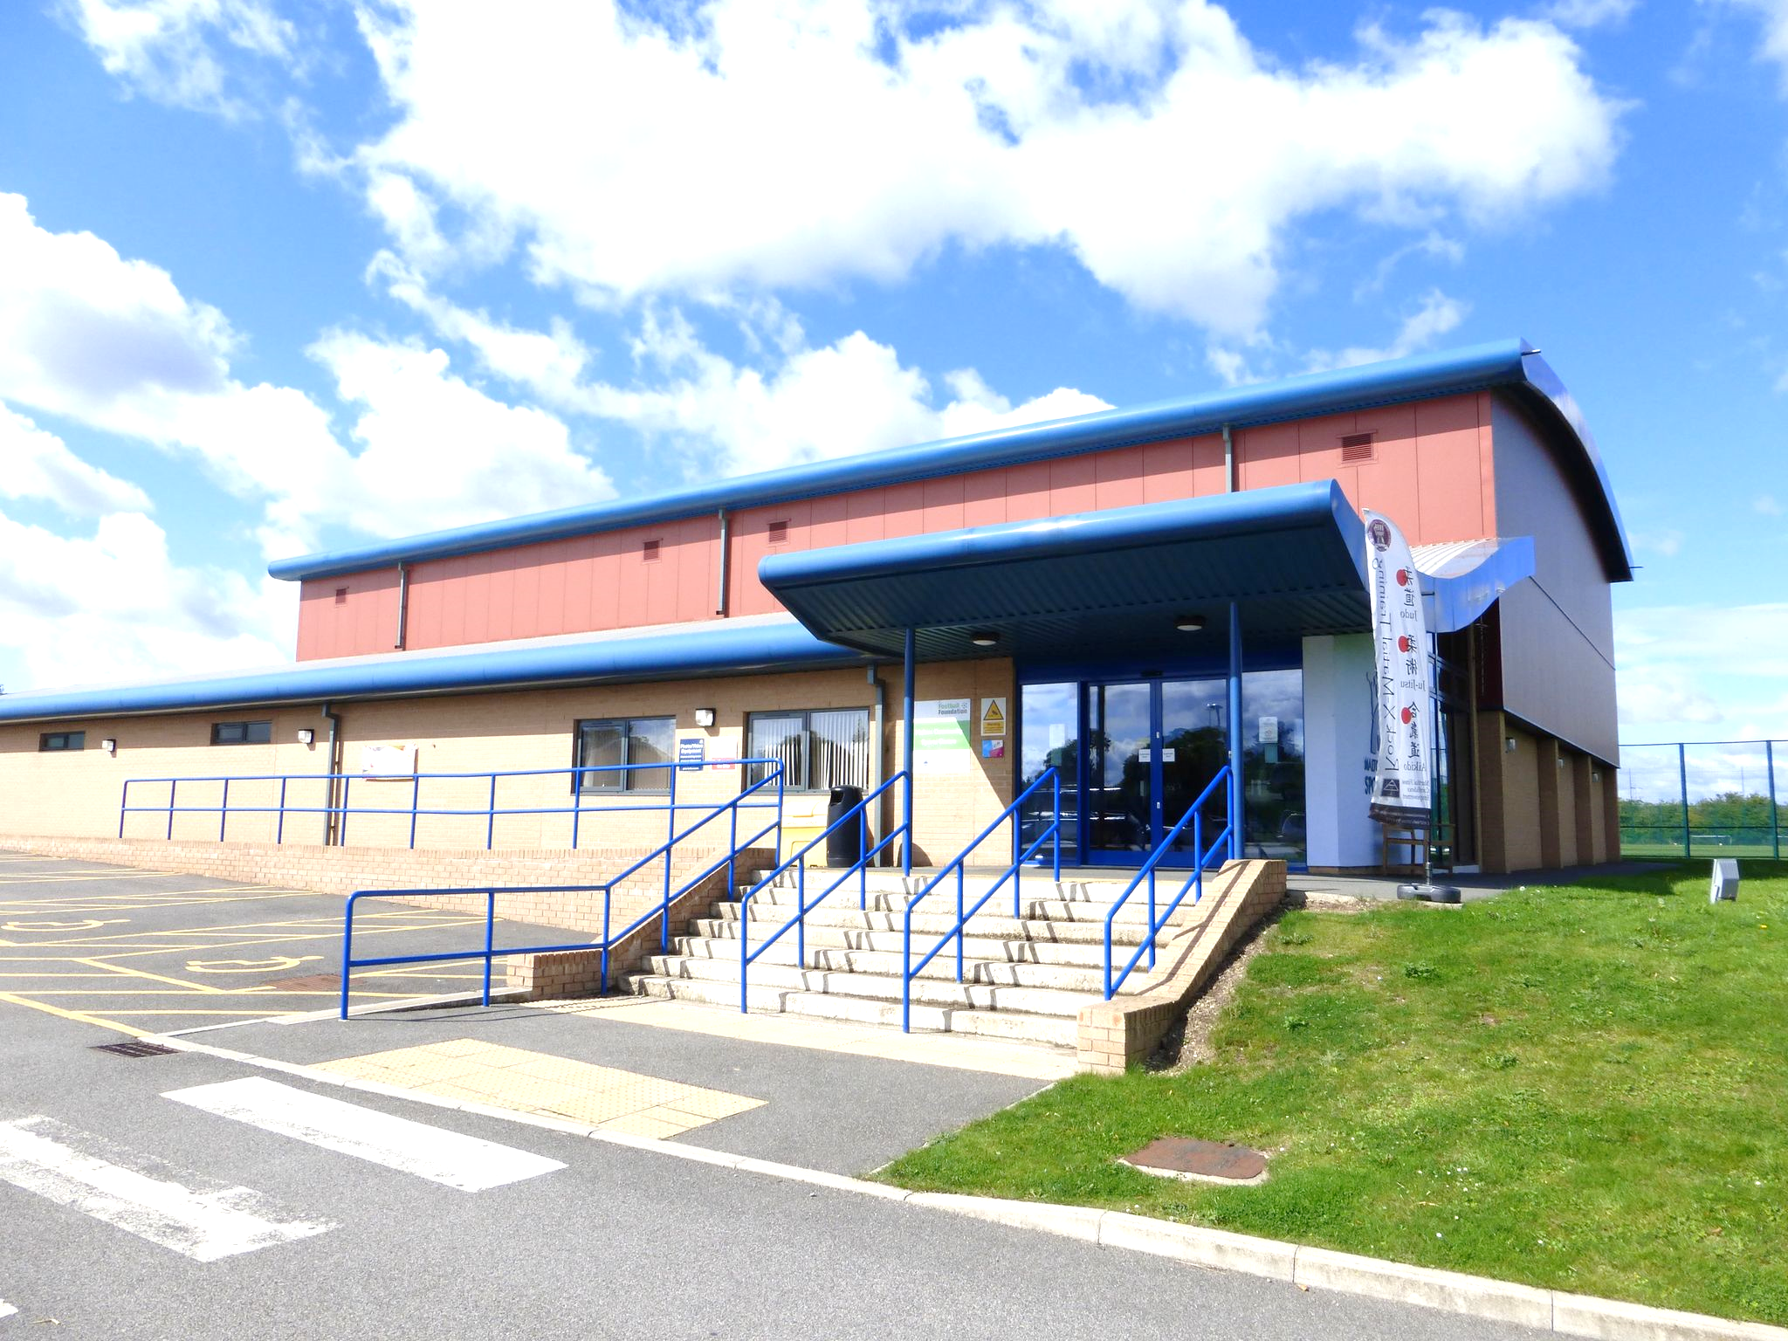
COMMUNITY FACILITIES
- Support development to upgrade provision at Norton Swimming Pool, including additional off-road parking (CF1)
- Support development to upgrade provision at Malton Community Sports Centre (CF2)
- Support development of a new and increased capacity at doctors’ surgery or medical centre (CF3)

TOURISM & CULTURE
- Support the development of new and extensions to museums and visitor facilities (TC1)
- Support the sympathetic development of new visitor facilities at Orchard Fields, subject to full protection of the site’s archaeological importance (TC2)
- Support new hotel provision either along the A64 or at a central location (TC3)
- Support a new hotel with public car parking capacity on the ‘upper deck’ of Wentworth Street Car Park (TC4)
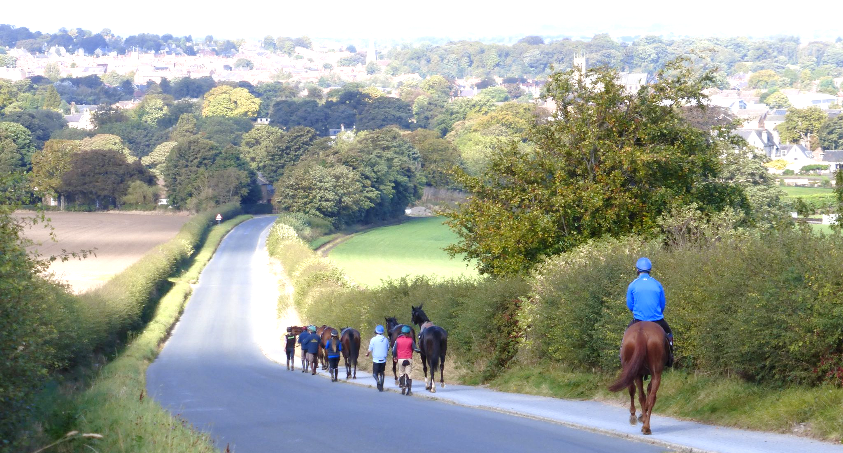
THE HORSE RACING INDUSTRY
- Safeguard existing horse racing stables (HRI1)
- Identify and protect identified ‘horse racing zones’, covering stables, gallops, and horse walking routes around stables, against adverse development (HRI2)
- Support improved pedestrian, cycleway and bridleway accessibility in the vicinity of horse racing stables (HRI3)
- Support the development of a horse racing museum (HR14)
HERITAGE & DESIGN
- Guide design and development within the towns’ 3 conservation areas so they reflect and take account of the areas’ special historic and architectural features (HD1)
- Guide design and development outside the conservation areas so they respect local distinctiveness and reflect good design principles (HD2)
- Guide design and development in relation to shop fronts in order to uplift the appearance of town centres/retail areas and present an attractive face to visitors and the local community alike (HD3)
- Support conservation area enhancements, and public realm improvements throughout the Neighbourhood Area (HD4-HD10)
- Ensure that the two towns’ archaeological remains are taken full and appropriate account of in any new development (HD11)
HOUSING
- Support a housing mix reflective of what you told us (bungalows, specialist accommodation for the elderly, a mix of smaller homes for owner occupation and non-private rented) on larger housing sites (0.4ha or more) and site providing 10 or more dwellings (H1)
EMPLOYMENT
- Support development proposals for employment generating uses in the food industry, tourism, horse racing, retail and green industries (EM1)
MALTON-SPECIFIC POLICIES
- Protects car parking capacity at Wentworth Street Car Park and supports environmental and operational improvements (M1)
- Protects car parking capacity at Malton Market Place and supports environmental and operational improvements (M2)
NORTON-SPECIFIC POLICY
- Support regeneration of land to the rear of Commercial Street, specifically for retail, light industrial uses and public car parking with rear service access to commercial properties. Residential and other uses vulnerable to flooding are not supported (N1)

